**UNIT-1**

**IMPORTANT QUESTIONS (~~FLAT~~)**

1. Construct Minimum state Automata for the following DFA?
   1. * Denotes final state

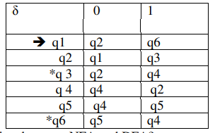

1. Differentiate between NFA and DFA?
2. Design DFA for the following over {a,b}.

i) All string containing not more than three a’s. ?

ii) All strings that has at least two occurrences of b between any two occurrences of a?

1. Construct a DFA accepting the set of all strings ending with 00? Define Finite Automaton?
2. Explain about the model of Finite Automaton?
3. Design a NFA for the following language L={0101 n  where n>0}
4. Construct Minimum state Automata for the following DFA ? * denotes final state

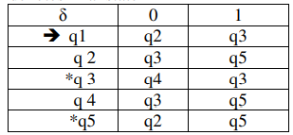

1. Explain in detail about Melay and Moore Machines?
2. How finite automata is useful for Natural language processing? Explain.
3. Give a DFA for Σ = {a, b} that accepts any string with aababb as a substring.
4. Design a Moore machine for 2’s complement of binary number
5. Give an ∈-NFA for strings of the form 01*0*1 over the alphabet Σ = {0, 1}
6. Explain the sequence of steps in converting the ∈-NFA obtained in previous question 2(a) to an equivalent DFA.
7. What are the elements of finite state system? Explain.
8. How FSM is mathematically represented? Discuss.
9. Construct DFA equivalent to NFA given in figure,

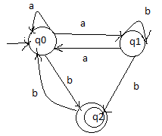

1. Construct DFA for the following: L = {w | w is in the form of ‘X01Y’ for some string X and Y consisting of 0’s and 1’s}.
2. Convert the below NFA to DFA:



1. a) With an example, explain the procedure for converting a Moore Machine into Melay machine.

b) Check whether the two DFAs (A) and (B) given below are equivalent or not.



1. a) Define Deterministic and Non-deterministic finite automaton.

b) Design an NFA with Σ = {0, 1} accepts all string in which the third symbol from the right end is always 0.

1. a) Convert the given NFA to equivalent DFA.



b) Construct a Moore machine that determines whether an input string contains an even or odd number of 1's. The machine should give 1 as output if an even number of 1's are in the string and 0 otherwise.

1. a) Why do we need to study automata theory and formal languages?

b) Define NFA with ∈- moves and give example.

c) Depict the steps in converting an NFA with ∈ into NFA without ∈ with an example.

1. a) Design a DFA L(M) = {w | w ε {0, 1}*} and W is a string that does not contain consecutive 1's.

b) Convert the following Mealy machine into equivalent Moore machine.

